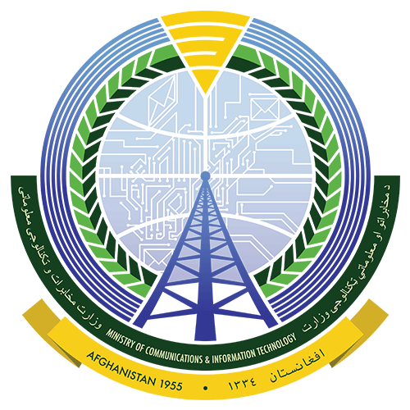
Islamic Republic of Afghanistan
Ministry of Communication and IT

Specific Procurement Notice

Request for Bids
Non-Consultancy Services

Contract Title: Procurement of Connectivity of 3 Hospitals
RFB Reference No.: MCIT-DC/PIU/2020/NC-11
Grant No.: IDA-D2820
Publish Date: December 01, 2020

- The Islamic Republic of Afghanistan has received financing from the World Bank toward the cost of the Digital CASA Afghanistan Project, and intends to apply part of the proceeds toward payments under the contract for Procurement of Connectivity of 3 Hospitals.
- The Ministry of Communication and Information Technology now invites sealed Bids from eligible Bidders for the provision of Procurement of Connectivity of 3 Hospitals in Kabul and Bamyan Provinces.
- Bidding will be conducted through national competitive procurement using a Request for Bids (RFB) as specified in the World Bank’s “Procurement Regulations for IPF Borrowers July 2016 Revised in November 2017 (“Procurement Regulations”) and is open to all eligible Bidders as defined in the Procurement Regulations.
- Interested eligible Bidders may obtain further information from Digital CASA Afghanistan Project – MCIT, Mr. Walid Noori, walid.noori@digitalcasa.gov.af and inspect the bidding document during office hours 09:00 to 15:00 hours at the address given below.
- The bidding document in English may be obtained by interested eligible Bidders upon the submission of a written application to the address below.
- Bids must be delivered to the address below on or before January 02, 2021 at 10:30 am Kabul Local Time. Electronic Bidding will not be permitted. Late Bids will be rejected. Bids will be publicly opened in the presence of the Bidders’ designated representatives and anyone who chooses to attend at the address below on the mentioned date and time.
- All Bids must be accompanied by a Bid Security of AFN 150,000 (One Hundred and Fifty Thousand Afghani).
- The address referred to above is:
Digital CASA Afghanistan Project – Ministry of Communication and IT
Walid Noori – Senior Procurement Specialist
MCIT, Mohammad Jan Khan Watt, Kabul, Afghanistan
Phone Number: +93 729 232 233
Email: walid.noori@digitalcasa.gov.af
Copy to: moh.seddiqi@gmail.com , fawad.anwarzai@digitalcasa.gov.af
Website: www.ageops.net , www.mcit.gov.af

