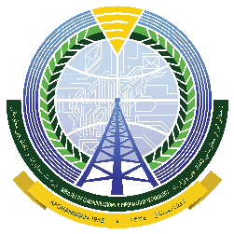
Grievance Registration Form
د افغانستان اسلامی جمهوری دولت
د مخابراتو او معلوماتی ټکنالوجۍ وزارت
دولت جمهوری اسلامی افغانستان
وزارت مخابرات و تکنالوژی معلوماتی

Digital CASA Project under the Ministry of Communication & Information Technology would like to know your concerns related to our project and our activities. The more information (including contact details) and supporting evidence provided, the more helpful it will be to our process. You may request us to keep your personal details confidential. The form is available in the national languages (Pashto and Dari) as well. Please put this form in the complaint box or submit it through email greivance@digitalcasa.gov.af or by phone (0744784100).
Complainant Contact Information
Name (optional)
Email
Phone
Address
Position

Please complete the relevant information below and provide a complete description of the complaint/grievance, including copies of all applicable supporting and relevant documents. Submit additional pages if necessary.
Subject
Date
Type of Complaint | Old | New | Ref. No, ‏ if Old complaint…
Description of complaint/grievance

