Islamic Republic of Afghanistan

Ministry of Communication and information Technology

Asan Khedmat
Asan Khedmat Second Service Center in Mhtab Qala, District 6 in Kabul

(One-stop shop for public services)

Transparency | Efficiency | Innovation

Terms of Reference
For

Mahtab Qla Asan Khedmat Second Service Center Design

Date:

Contents:
Asan Khedmat Mhtab Qla Construction Project second service Centre design TOR.1
Islamic Republic of Afghanistan 2
Ministry of Communication and information Technology 2
1 About Asan Khedmat: 3
2 Background: 4
3 Aim of the establishment of Asan Khedmat public service center: 4
4 Guidelines, which include amongst others: 4
5 The service provider will also be expected to: 7
6 Specific Scope of the Services: 7
7 The Architectural and Design Deliverables: 7
8 Equipment to be provided by the consultant: 8
9 Reporting 8
10 Requirement of the Ministry of Urban Development and Housing (MUDH) for project design complete package (visa) approval: 9
11 Qualification of the key personnel: 9
12 Qualifications Requirements: 9
13 17. Minimum Time-inputs required: 10
19. Payment Schedule: 10
14 Asan Khedmat second services center site location 7000sq meter are at Mhtab Qalh in Kabul district- 6 11
15 Asan khedmat Second Service Center Site Sketch 13

About Asan Khedmat:
Asan Khedmat is a one-stop shop for public services of Afghanistan established in July 2016, under the auspices of the Ministry of Communication & information technology. It is aiming at simplifying public services provided to businesses and population of Afghanistan. It has been more than two years that the Asan Khedmat has formally been established. Past year marked a period of laying ground for full launch of the services during 2018. During this period, Asan Khedmat experts have accumulated an enormous amount of information on the current state of affairs of the government services and shortlisted close to 50 of those services for simplification.18 of these services have already been simplified and up to 20 are lined to be simplified by the end of 2017.

Background:

The new initiative called Asan Khedmat, under the auspices of the Ministry of Communication and information technology (MCIT) which was approved by the Economic Council of Ministers in its meeting on March 19- 2016, is a one-stop shop for government services and auxiliary services from the private sector. Asan Khedmat in Afghanistan is perceived to be a major step towards raising the performance level of the Afghan government by increasing efficiency and effectiveness and enhancing the responsiveness to the needs of the Afghan citizen. The center shall help to deliver quality services in an inexpensive and timely manner and have a positive effect on the relation between citizen and government, making the work of the government employees, who bear the shortcomings of the present system, more fulfilling.
The idea behind this concept is to have common government services under one roof, thus shortening ways for the citizen and improving efficiency, which in turn results in greater citizen satisfaction. The services are delivered by the staff of the service-delivering agency, trained in the same way and clad in the same uniforms as the ASAN operational staff
The Asan Khedmat initiative is planning to build a twin building which accommodates on the one hand the first Asan Khedmat Service Centre, and which, on the other hand, accommodates the Public Services Support Agency, which is the parent organization for all Asan Khedmat Service Centers. Both buildings are designed and structured in accordance with strict

Aim of the establishment of Asan Khedmat public service center:
To reduce an extra expensed and loss of the time by the citizens;
To achieve observing the respected to the ethical rules and the kind behavior the citizens;
To increase transparency and strengthen the fight against corruption;
To ensure a larger use of electronic services;

Guidelines, which include amongst others:

Ability to cope with the rush of large numbers of citizens without obstruction
Facilitate easy guidance of the citizens seeking public services
Accommodate special infrastructure for information and communication technology
Accommodate security needs
Accommodate training facilities
Facilitate ISO 9001 compatibility
Building code requirements for structural concrete (ACI 318-08)
Earthquake – resistant structure design
General scope of the building drawing and technical specification, 1. four story building 2. three story buildings 3. two story building and one-story hall buildings include of the all related component like generator room, power room, power supply system, drainage system inside the center road and footpath with lighted system, greenery, landscape base on design
All drawing list should be printed by A1 and A2 size the mentioned dimension should be visible and used standard taxes
ASTM standard taste and all concrete tests max design and quality control documentation should be complete.
It is expected that the design and engineering deliverables adhere to modern standards rendering exterior and interior 3D visualization, and project animation video more than one-minute, three hard copy of the printed design requirements base on above mentioned size and quality entire package and within last presentation etc.

Objectives of the assignment:

The assignment has the objective to hire a consultant for complete engineering deliverables for the construction of second Service Center in Kabul city at Mahtab Qala location of Asan Khedmat in Afghanistan base on Asan Khedmat requirements destining with modern data base and all IT networking and facilities.

Detailed Description of the Assignment:

The Government of the Islamic Republic of Afghanistan has established Asan Khedmat under the auspices of the Ministry of communication and information technology MCIT, which is a one-stop-shop for public services and which incorporates public services and auxiliary services from the private sector under one roof.
The program shall culminate in the establishment of a services center with an own building, operating under the authority and supervision of an independent entity which shall be established.

The second step for establishing the Asan Khedmat Services center in Kabul Mahtab Qala, in 7000 sq. meter area planned which replicates and adapts the concept as per requirements of Asan Kkedmat is to designing the second customized services center. A key requirement of this design is to replicate the ASAN Khedmat model, to minimize site impacts and the visual impression of the building itself. The design complete package of the second center design of the building must consider the exclusive shapes of the landscape and the unique character related to Public Services. The proposed design should evolve from ICT system, e-Governance, Data Center, queuing system, CCTV camera, HVAC drawing, fire bridge system, central AC system, should response to the ISO 9001 standard and aim to be sensitive to the fragile public services. The design would aspire to be in harmony with nature through its minimal impact, form earth-tone template and through maximizing the use of natural systems. The design character should be in tune with the architecture of ASAN Khedmat models facilities.

After signing the contract, the selected consultant is to perform the design of second Asan Khedmat center building, prepare the tender document, and prepare the supervision and quality management and quality control and safety all mentioned manuals and as per standard design and assist during implementation of the project if find any difficulties because some small design some time not applicable that is the designer company responsibility relative the design report or solve the problem and design company prepare max design of concrete and all test manual document even project work plan

The second Asan khedmat center should be designed to include head of the center, de offices, overall operation (HR, Finance, Admin, IT, Support, Procurement, Transport), offices, training staff offices and standard training facilities, monitoring and assessment staff office, legal department, e-governance staff office, policy and planning, provincial centers support facilities, in relation, call center, complaint center and secure data center clients service cabins and civil maintenance department
The second Asan Khedmat center should be designed to facilitate the following services to integrate and offer such as Car registration, renewal of driving license, taxi licensing, criminal record, passport, marriage certificate, divorces certificate, birth certificate, death certificate, ID card, Insurance, work permit (local and expats), tax payer’s registration, TIN, pension, health documents, business and trade documents, documents attestation etc. In addition to these public services, the following auxiliary services may be integrated and offered in the service center Government services, insurance services, legal assistance services, translation services, medical services, photo services, travel agency services, tourism services, internet facilities, water and electricity bills, children's area, mosque, parking, etc.

In buildings meeting and conference rooms, storerooms, reception, kitchen facilities, toilet facilities for the offices and clients, accommodation for the deputy staff and a wall and a gate
Site visit, soil test analysis, topographical survey, concept and theses development, detail design and engineering deliverable are required and strong foundation that endures multiple floors.
The Architect will be responsible to do the monitoring of construction work of the construction work and will be responsible for checking that the construction conforms to the planning permission and Building Regulations and all stages are properly completed to a satisfactory standard of workmanship. This will involve periodic site visits to monitor progress (visually), but will not normally involve detailed checking of dimensions or testing materials. The contractor, on site, will supervise the work on a day-to-day basis and be responsible for the proper carrying out and completion of construction works and for health and safety provisions on the site.

The presentation of the design of the second Asan Khedmat center building includes the following work:
Prepare designs as mentioned in the all-necessary components for the building;
The design will include sketches, incubation work phase of work, concept and thesis development work, detail design and engineering development;
Prepare all necessary construction documents including working drawings, architectural, structural, mechanical specifications;
Supervise the construction firm of the building In cooperation with the Ministry of information and technology
All construction design manuals

The service provider will also be expected to:

1. Visit the site and discuss the details to be familiarized with all aspects of the project;
2. Prepare a design that suits the use of ASAN Khedmat Model where possible;
3. Prepare a design that suits the use of suitable local traditional materials for construction;

Specific Scope of the Services:
Preliminary & detailed design and preparation of including Drawings, Technical Specifications, BoQ and cost estimate that shall include the following tasks:

Task 1:
Visit, site topography survey site plan and analyze site
Build model of site
Well design
Develop concept model
Report on design process

Task 2:
Perform environmental and structural analysis
Build final models
Report on design process

Task 3:

- Building site model
- Soft copy of design and reports in CD
c. Building concept model
d. Building architectural model
e. Building sketch model
Draft Final Report, after detailed design phase

The Architectural and Design Deliverables:
Building final model
b. 3D visualization interior
c. 3D visualization exterior
d. Construction drawings
e. Fabrication drawings
f. Structural details
g. Electrical drawings
h. İT communication plan
i. Firefighting plan
j. HVAC system drawings
k. CCTV system drawings
l. Mechanical drawings
m. Water supply and drainage system
n. Landscape design drawings
o. Infrastructure system
p. Engineering calculations
q. BoQ and cost estimate

Approval of Final Report (two weeks after initiation)
Completion design package of the Mahtab Qala second Asan Khedmat center and presentation
Mahtab Qla construction project scope
Mahtab Qla construction project bid entire documents
Power system (electrical system design)
Power supply complete design
Mechanical system complete design
3D visualization exterior and interior rendering and more than one minute video clip
Water supply and drainage system connect to septic system and septic design
Landscape design drawings
Infrastructure system
For all system detail reports
Boundary wall design and guard tower design
Road and site plane electrical design
Setup of the small component of the building (security building, power, ground parking, drainage, footpath, and fountain and greenery within drawing section of all design
Architectural external shape (modal) of the building
Project design animation video
Technical specification for design
Whole design related documents and drawings
Revised BoQ and cost estimate sheet and cost of the project
Fabricated infrastructure well design by detail water reservoir
Laboratory final report provided by Design Company geological survey and geo technical investigation carry out at the new construction site at Mhtab Qla are in 7000 sq meter area

Duration of the Services
The duration of the Services is to extend from the date of effectiveness of the Contract for a period of approximately: 2 Months

Equipment to be provided by the consultant:
As detailed under Section 5 herein above, the Consultant should arrange all facilities required for the consultancy service by him and the cost of such provision should be detailed in the Consultant’s financial proposal and will be consider its need from the evaluation team of Asan Khedmat.

Reporting
Reports shall be generated after the completion of design. the incubation and inception phase, concept and thesis development phase and the detailed change design phase. The inception and the interim reports shall be submitted electronically to the Director of Asan Khedmat. The final report shall be submitted on CD and as hardcopy in duplicate.

Requirement of the Ministry of Urban Development and Housing (MUDH) for project design complete package (visa) approval:

Table of content, project site survey plan(koroky) approved form Kabul municipality or MUDH all plan of the architecture within inside and out site diminution, design section details for each potion , emergency stairs with direction, furniture plan for to each floor, prospective wives of the building, vertical and horizontal section of the required drawings, landscape plan within all sections roads footpaths drainage within all details, site plan of the project (2D-3D) full detail of the floor, wall, stairs etc. numbering of doors windows in plans, description table of the doors and windows, drawing heading tax size and one font ,list of the project completion of external and internal with description end of the project hand over time, designer update license and education documents within company update license, , bathroom section details, safety plan, volume of project, and cost (BoQ)

Staffing and Skill Needed
The successful team will be comprised of both local and international experts with the specific experience and background noted. It is suggested that in putting together its team, consultants consider designating individuals with the following roles, responsibilities and backgrounds:

Qualification of the key personnel:

Number of Positions needed –Change Design
Position K-1: [Team Leader - Architect]
Position K-2: [Civil/ Structural Engineer]
Position K-3: [Electrical Engineer]
Position K-4: Water supply & Sanitation Engineer
Position K-5: Mechanical

Qualifications Requirements:
Position | Academic Qualification | Experience
Team Leader (Architect) | A degree in Architecture or Civil Engineering from a recognized university.  Membership to professional body is desirable. | Minimum 10 years of overall experience in the implementation of project of similar nature.  at least 5 years of experience in a management position with responsibility of achieving the overall project output  Experience in region will be an advantage.
Civil/ Structural Engineer  Electrical Engineer  Mechanical Engineer  Water supply & Sanitation Engineer | A degree in engineering (relevant disciplines) from a recognized university | Minimum 5 years of overall experience in the implementation of project of similar nature.  at least 5 years of experience in a similar position.  Experience in region will be an advantage.

17. Minimum Time-inputs required:

No. | Staff Position | Number | Estimated Person Month
Key Professional Staff
1 | Team Leader (Architect) | 1 | 5
2 | Civil/ Structural Engineer | 1 | 4
3 | Electrical Engineer | 1 | 3
4 | Mechanical Engineer | 1 | 3

19. Payment Schedule:
Complete Design of the second Asan khedmat center and geo technical investigation at new project site with all required test and report, Lump sum Contract amount will be paid as follows:

Twenty (20) percent of the Contract Price shall be paid on the commencement date against the submission of an inception report including detailed work plan and full mobilization of the project personnel after 10 days;

Forty (40) percent of the lump-sum amount shall be paid upon completion of the preliminary design and subsequently development of detailed design drawings, specifications, cost estimates and Bill of Quantities as to be approved by Asan khedmat technical engineering team.

Thirty Five (35) percent of the lump-sum amount shall be paid upon submission of the final report including a presentation of overall engineering design and architectural aspects of the buildings mentioned change design, complete documentations containing finalization of the technical evaluation requirements of the bids for construction, complete design drawings, specifications and BoQ as to be approved by MCIT and Asan khedmat technical team.

Ten (5) percent of the amount will be retained and shall be paid upon completion of the approval design from MUDH and Asan Khedmat engineering team and design and handover to the client via acceptance report.

Asan Khedmat second services center site location 7000sq meter are at Mhtab Qalh in Kabul district- 6

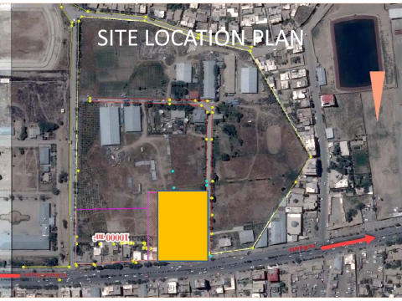

7000sq m

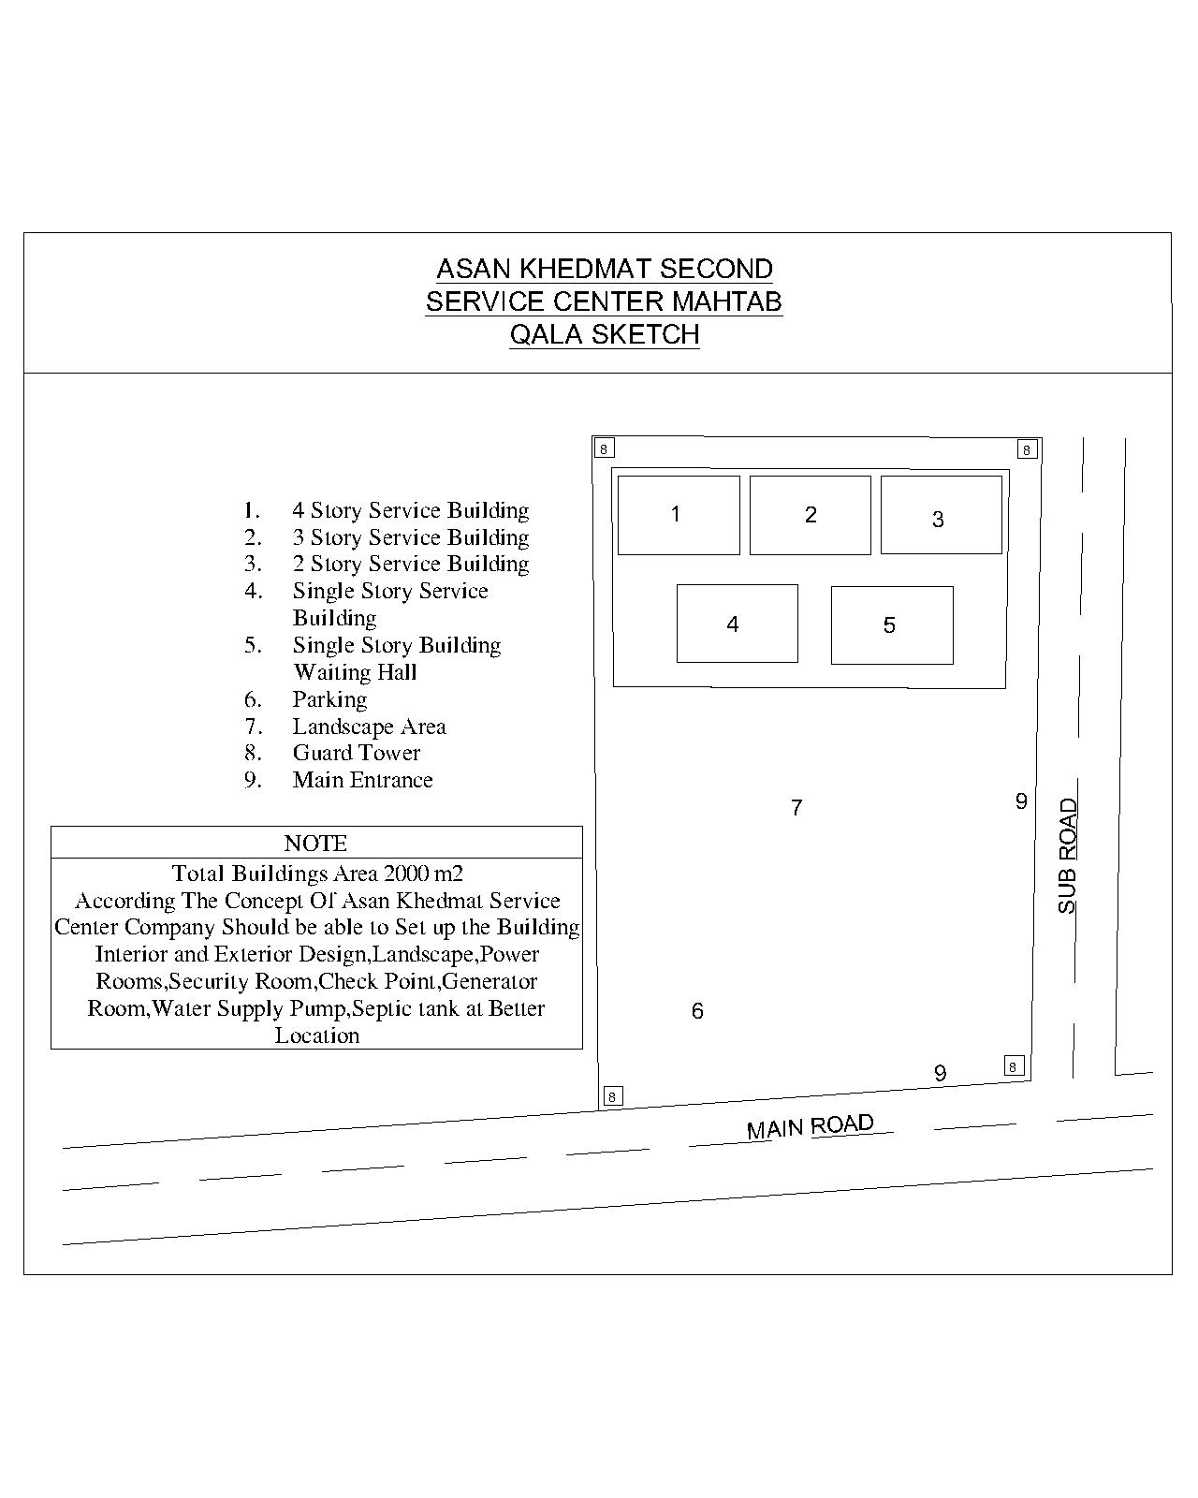
Asan khedmat Second Service Center Site Sketch
3

